

**Hostel Management System**

**Submitted By:**

**Tajammal Maqbool, 2020-CS-36**

**Submitted To:**

**Dr. Awais Hassan**

**For Fulfilment of**

**CS 142 Object Oriented Programming**

**Department of Computer Science**

**University of Engineering and Technology, Lahore**

**Contents:**

**Topic Page No.**

* **Functional Requirements ……………………………………………………………….03**
* **Case Model…………………………………………………………………………………….05**
* **Classes Model…………………………………………………………………………………06**
* **Web Service Detail………………………………………………………………………….08**
* **Low Fidelity…………………………………………………………………………………….16**
* **High Fidelity CLI………………………………………………………………………………17**
* **High Fidelity Web……………………………………………………………………………19**
* **Sequence Diagram…………………………………………………………………………40**
* **Test Cases………………………………………………………………………………………41**
* **Add Features………………………………………………………………………………….43**

**Functional Requirements:**

* User Must login with a Username & Password in Order to use the System.

**Owner:**

* Can add a New Manager.
* Can View All person’s Name & No. of Allotted Rooms.
* Can view Total Amount of Allotted Rooms.
* Can Send Message to Manager & Receive all Messages from Manager.
* Can Change Password of His Account.
* Can logout.

**Manager:**

* Can add a New Person.
* Can View All person’s Name & No. of Allotted Rooms.
* Can view Total Amount of Allotted Rooms.
* Can Send Message to Owner & Receive all Messages from Owner.
* Can change Price of Room.
* Can add Any Fast Food.
* Can view Fast Food List
* Can Add A Worker.
* Can Add a Room
* Can receives All complains from all person.
* Can View Detail of All Workers.
* Can delete Resident , Room , Fast Food and Worker
* Can change password of his Account.
* Can logout.

**Resident:**

* Can get Allotment of Room.
* Can order Any Fast Food.
* Can view Fast Food List in Descending order.
* Can Send any Complain to Manger.
* Can view All Ordered Fast Foods
* Can View About Hostel.
* Can change password of his Account.
* Can logout.

**Case Model:**

Owner

Manager

Residents

**Classes Model:**

**For Residents:**

**ID**

**name = (string)**

**email = (string)**

**pin = (string)**

**roomNo = (int)**

**roomType = (string)**

**expenditures =(int)**

**myOrderedFoods = []**

**addOrderedFoods()**

**OrderFoods**

namefood = (string)

quantity = (int)

price = (int)

1 infinite

**For Workers:**

**Workers**

name = (string)

job =(string)

salary = (int)

**For Foods:**

**Foods**

name = (string)

price = (int)

quantity = (int)

**For Rooms:**

**Rooms**

typeRoom = (string)  
priceRoom = (int)

toatalRoom = (int)

bookedRooms = (int)

startingRoom = (int)

**Web Service Detail:**

@app.route("/")

mainLoginPage.html

**# Owner Pages**

@app.route("/loginowner")

Owner/loginOwner.html

@app.route("/ownerhome")

Owner/owner.html

@app.route("/createAccountManager")

Owner/registerManager.html

@app.route("/sendMessage")

Owner/sendMessageToManager.html

@app.route("/recieveMessage")

Owner/recieveMessageOwner.html

@app.route("/residentsDetail")

Owner/residentDetail.html

@app.route("/workersDetail")

Owner/workersDetail.html

@app.route("/room")

Owner/roomsDetail.html

@app.route("/sendMessageByOwner", methods=['POST', 'GET'])

Owner/sendMessageToManager.html

@app.route("/owner", methods=['POST', 'GET'])

Owner/owner.html

or

Owner/loginOwner.html

@app.route("/profileowner")

Owner/profileOwner.html

@app.route("/profilemanagerOwner")

Owner/profileManager.html

@app.route("/signupmanager", methods=['POST', 'GET'])

Owner/owner.html

@app.route("/registerMyOwner")

Owner/registerOwner.html

@app.route("/myregisterOwner", methods=['POST', 'GET'])

Owner/loginOwner.html"

@app.route("/forgotpinowner")

Owner/forgotpinowner.html

@app.route("/changepasswordowner")

Owner/changeownerpin.html

@app.route("/changePinMyOwner", methods=['POST', 'GET'])

Owner/owner.html

Or:

Owner/changeownerpin.html

@app.route("/frogotPinOwner", methods=['POST', 'GET'])

Owner/loginOwner.html

or:

Owner/forgotpinowner.html

**# Manager Pages**

@app.route("/profilemanager")

Manager/profileManager.html

@app.route("/loginmanager")

Manager/loginManager.html

@app.route("/managerhome")

Manager/manager.html

@app.route("/sendMessageManager")

Manager/sendMessageToOwner.html

@app.route("/recieveMessageManager")

Manager/recieveMessageManager.html

@app.route("/createAccountresident")

Manager/registerResident.html

@app.route("/registerResident", methods=['POST', 'GET'])

Manager/manager.html

@app.route("/addWorker")

Manager/WorkerAdd.html

@app.route("/addFood")

Manager/foodAdd.html

@app.route("/residents")

Manager/residentDetail.html

@app.route("/workers")

Manager/workersDetail.html

@app.route("/Rooms")

Manager/roomsDetail.html

@app.route("/foods")

Manager/foodDetail.html

@app.route("/deleteResident",methods=[‘POST’.’GET’])

Manager/residentDetail.html

@app.route("/deleteWorker",methods=[‘POST’.’GET’])

Manager/workersDetail.html

@app.route("/deleteRoom",methods=[‘POST’.’GET’])

Manager/roomsDetail.html

@app.route("/deleteFood",methods=[‘POST’.’GET’])

Manager/foodDetail.html

@app.route("/complains")

def Mycomplains():

Manager/recievedComplains.html

@app.route("/addworker", methods=['POST', 'GET'])

Manager/manager.html

@app.route("/manager", methods=['POST', 'GET'])

Manager/manager.html

or:

Manager/loginManager.html

@app.route("/sendMessageByManager", methods=['POST', 'GET'])

Manager/sendMessageToManager.html

@app.route("/addFastFood", methods=['POST', 'GET'])

Manager/foodDetail.html

@app.route("/changepasswordmanager")

Manager/changemanagerpin.html

@app.route("/forgotmanagerpin")

Manager/forgotpinmanager.html

@app.route("/changePinMyManager", methods=['POST', 'GET'])

Manager/manager.html

or:

Manager/changemanagerpin.html

@app.route("/frogotPinManager", methods=['POST', 'GET'])

Manager/loginManager.html

or:

Manager/forgotpinmanager.html

@app.route("/changinRoom")

Manager/Rooms.html

@app.route("/addanewmyRoom", methods=['POST', 'GET'])

Manager/roomsDetail.html

**# Login Resident**

@app.route("/login")

Resident/loginResident.html

@app.route("/profileresident")

Resident/profileResident.html

@app.route("/resident")

Resident/resident.html

@app.route("/getRoom")

Resident/allotmentofRoom.html

@app.route("/orderfood")

Resident/orderFood.html

@app.route("/orderfooddetail")

Resident/orderedfoods.html

@app.route("/foodDetail")

Resident/foodDetails.html

@app.route("/sendComplains")

Resident/sendComplains.html

@app.route("/sendComplain", methods=['POST', 'GET'])

Resident/sendComplains.html

@app.route("/success", methods=['POST', 'GET'])

Resident/resident.html

Or:

Resident/loginResident.html

@app.route("/forgotpinresident")

Resident/changeresidentpin.html

@app.route("/changepinresident")

Resident/forgot-pin-resident.html

@app.route("/changePinMyResident", methods=['POST', 'GET'])

Resident/resident.html

or:

Resident/changeresidentpin.html

@app.route("/frogotPinResident", methods=['POST', 'GET'])

Resident/loginResident.html

or:

Resident/forgot-pin-resident.html

@app.route("/getnewRoom", methods=['POST', 'GET'])

Resident/resident.html

or:

Resident/allotmentofRoom.html

@app.route("/orderfoodnow", methods=['POST', 'GET'])

Resident/orderedfoods.html

or:

Resident/orderFood.html

**# Other People**

@app.route("/peoplehome")

people.html

@app.route("/applyresidence")

ResidenceApply.html

@app.route("/applyjob")

ApplyJob.html

**Low Fidelity:** 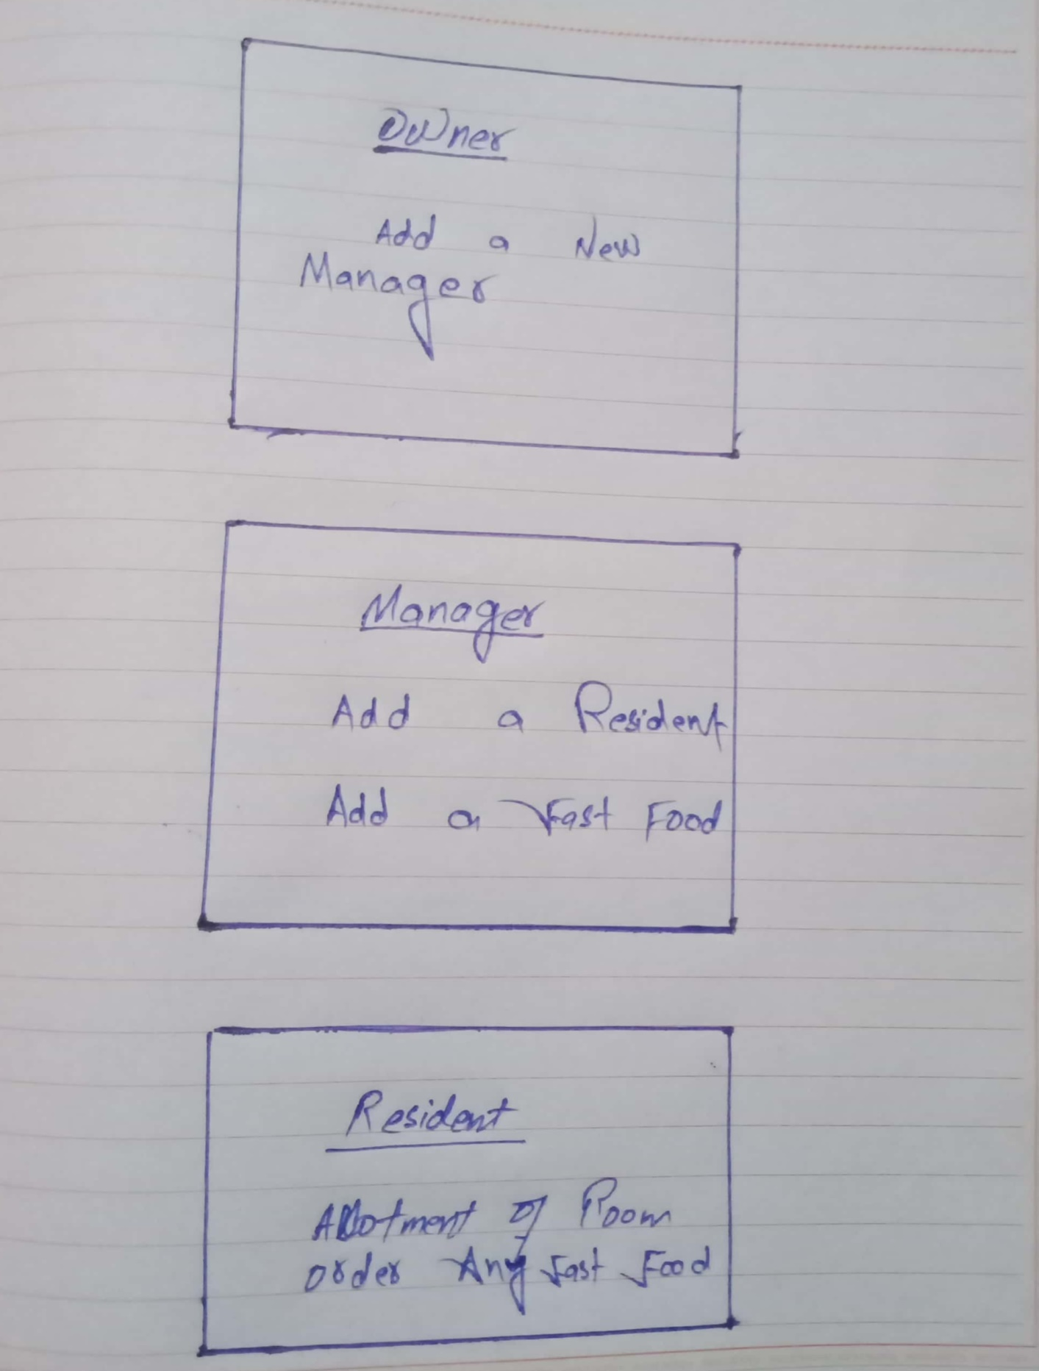

**High Fidelity CLI:**

**Main:**

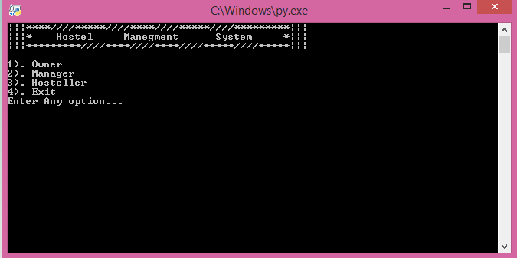

**Owner Interface:**

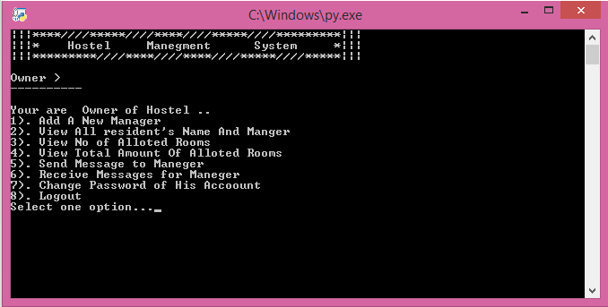

**Manager Interface:**

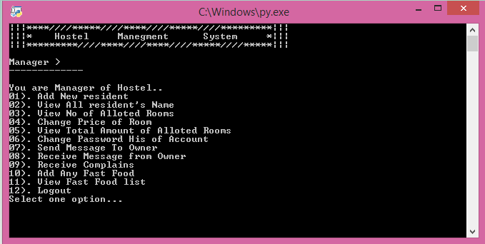

**Resident Interface:**

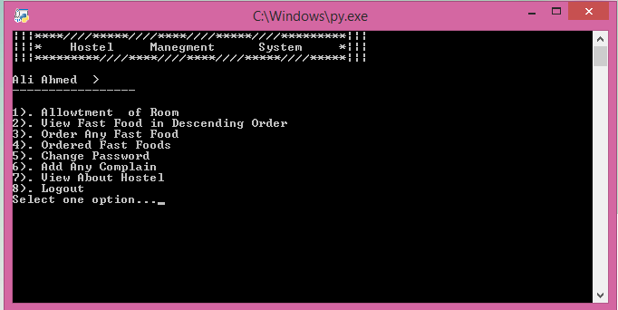

**High Fidelity Web:**

**Main Login Page:**

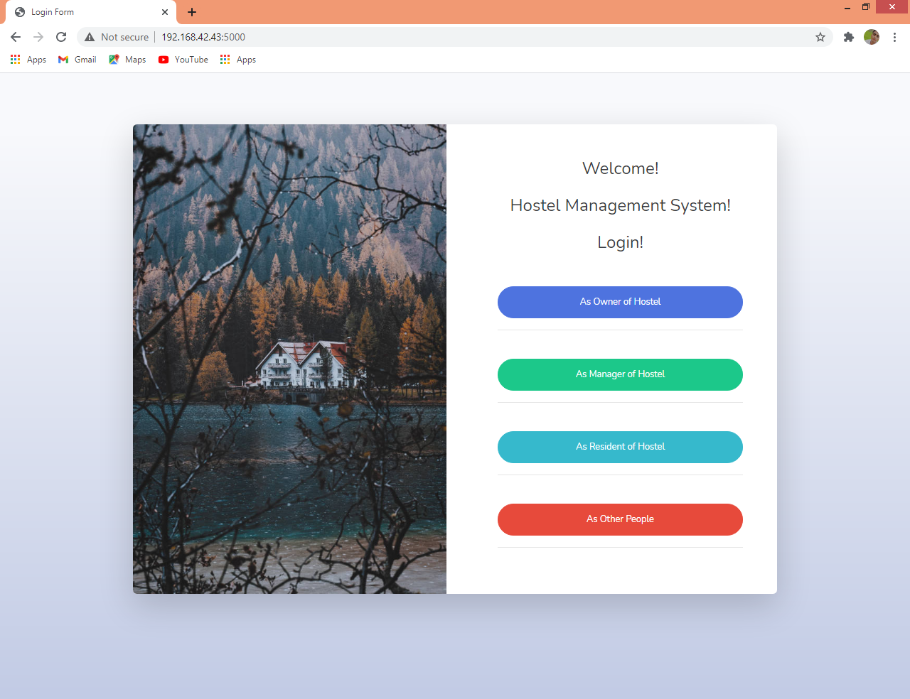

**Owner Login Page:**

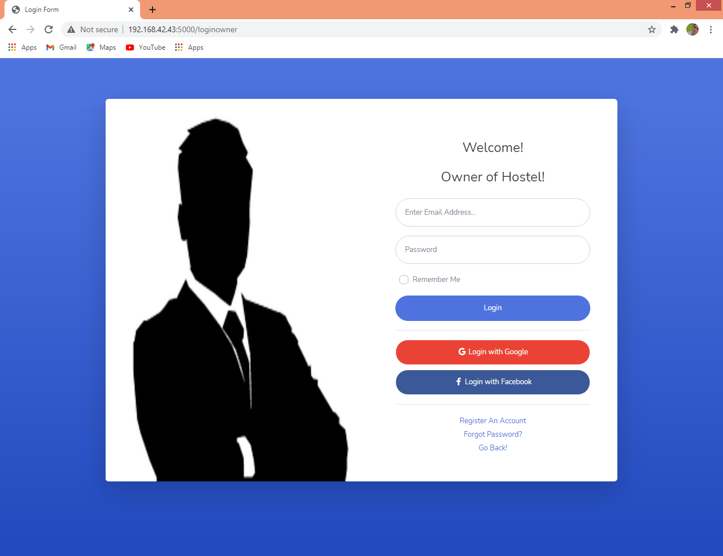

**Owner Page:**

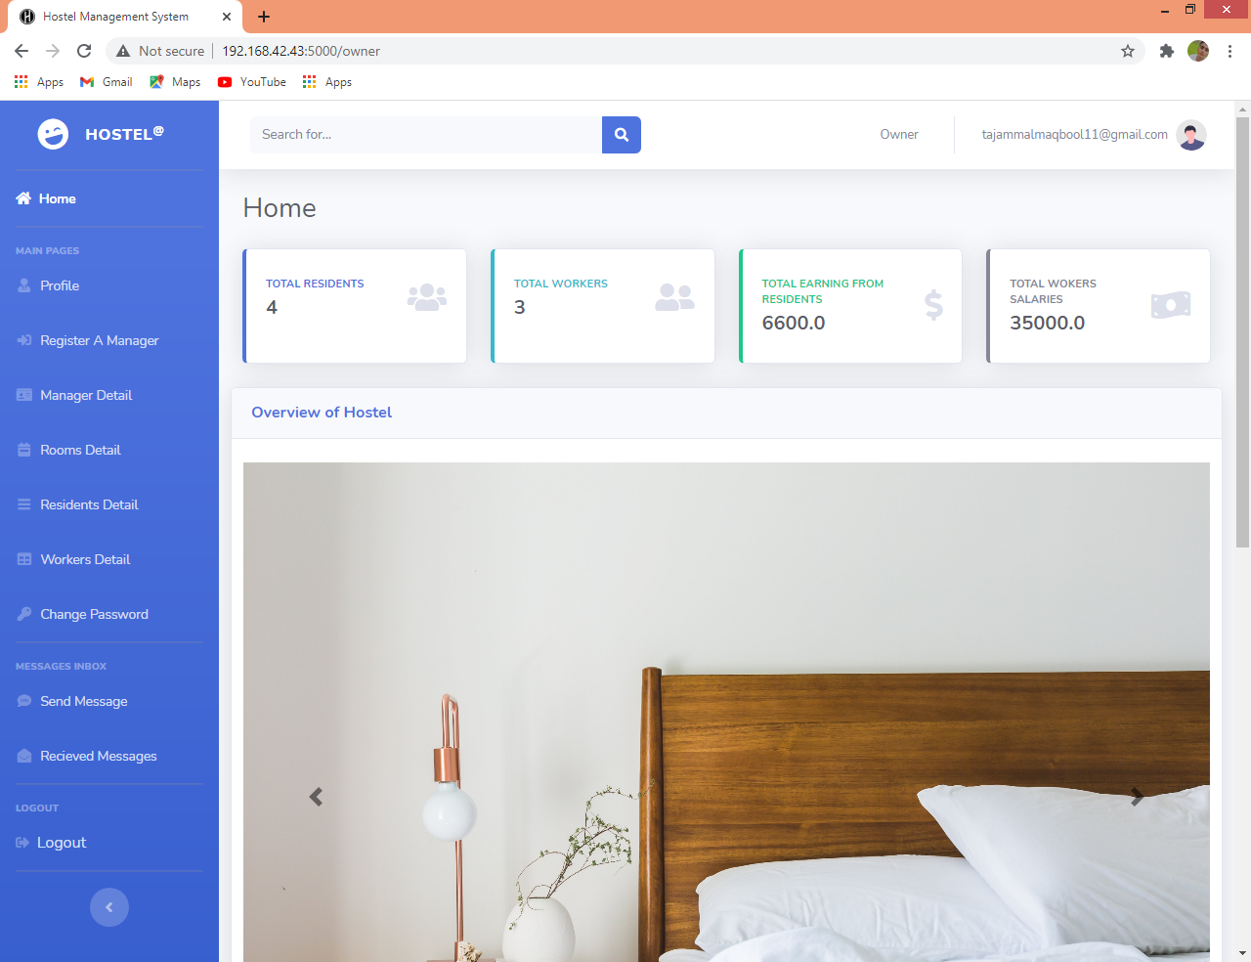

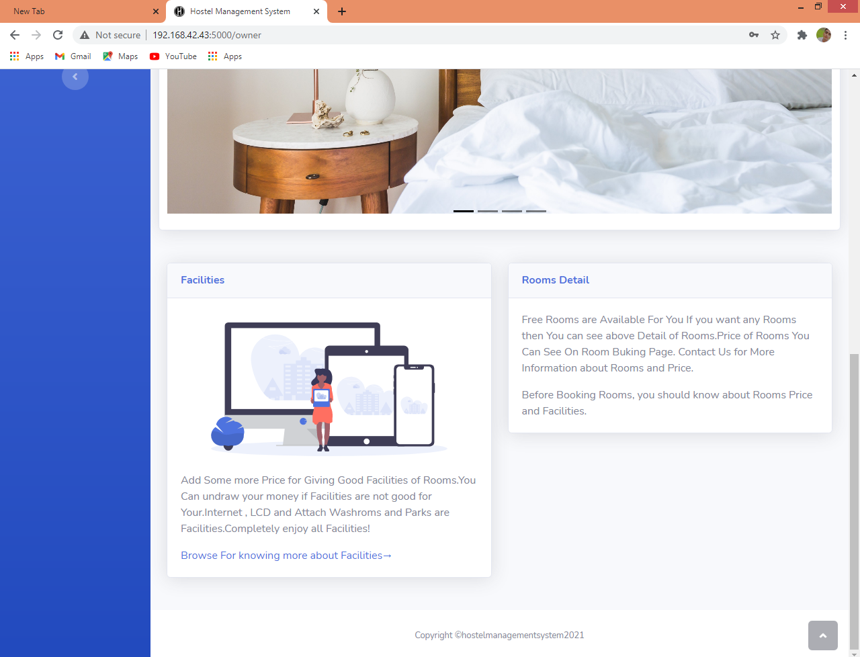

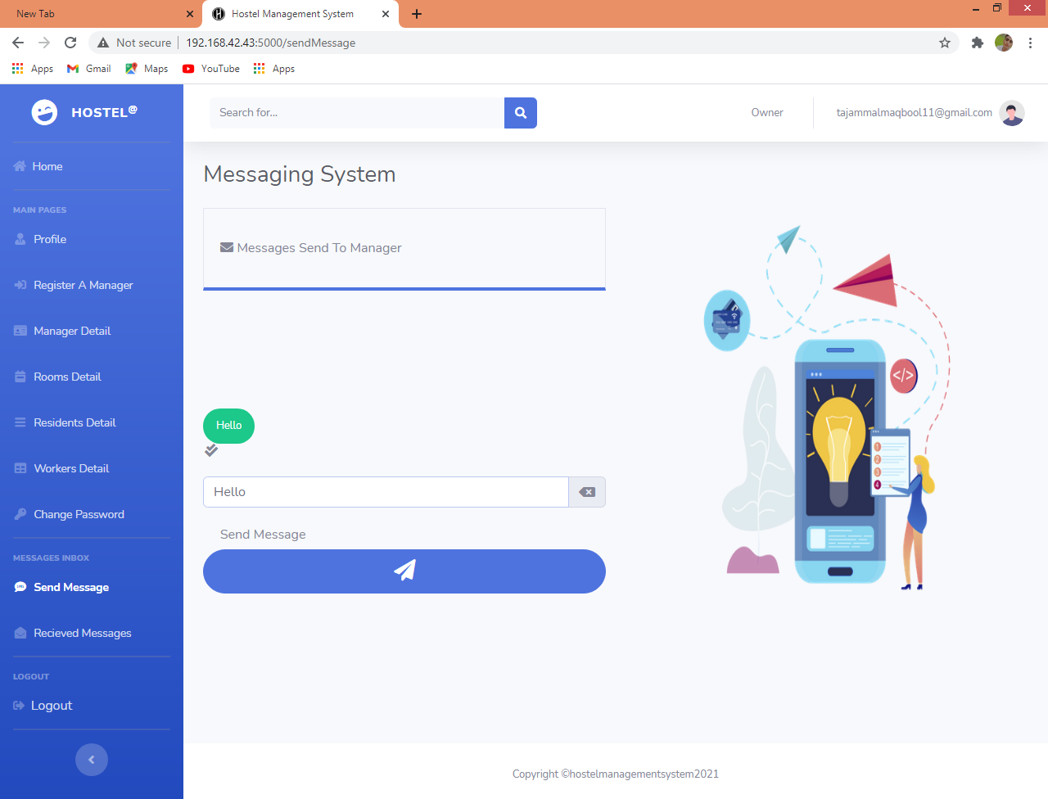

**Manager Login Page:**

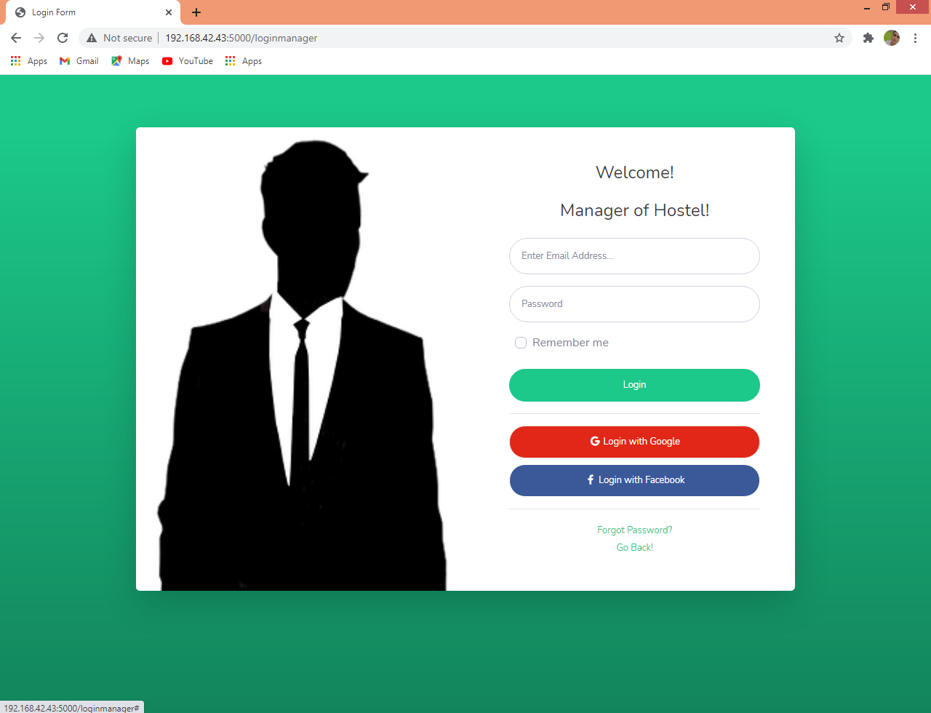

**Manager Page:**

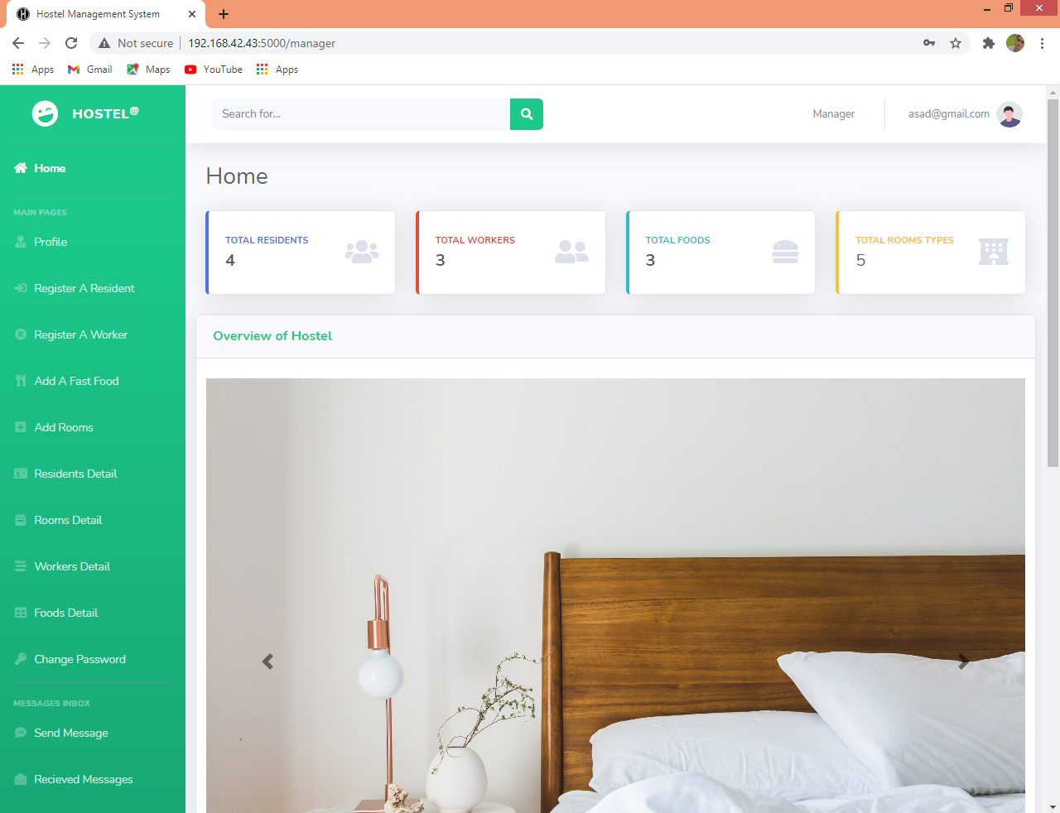

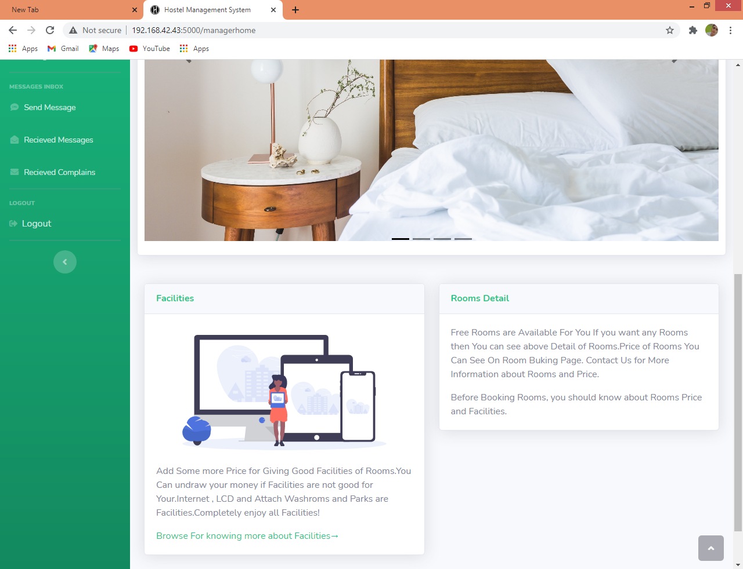

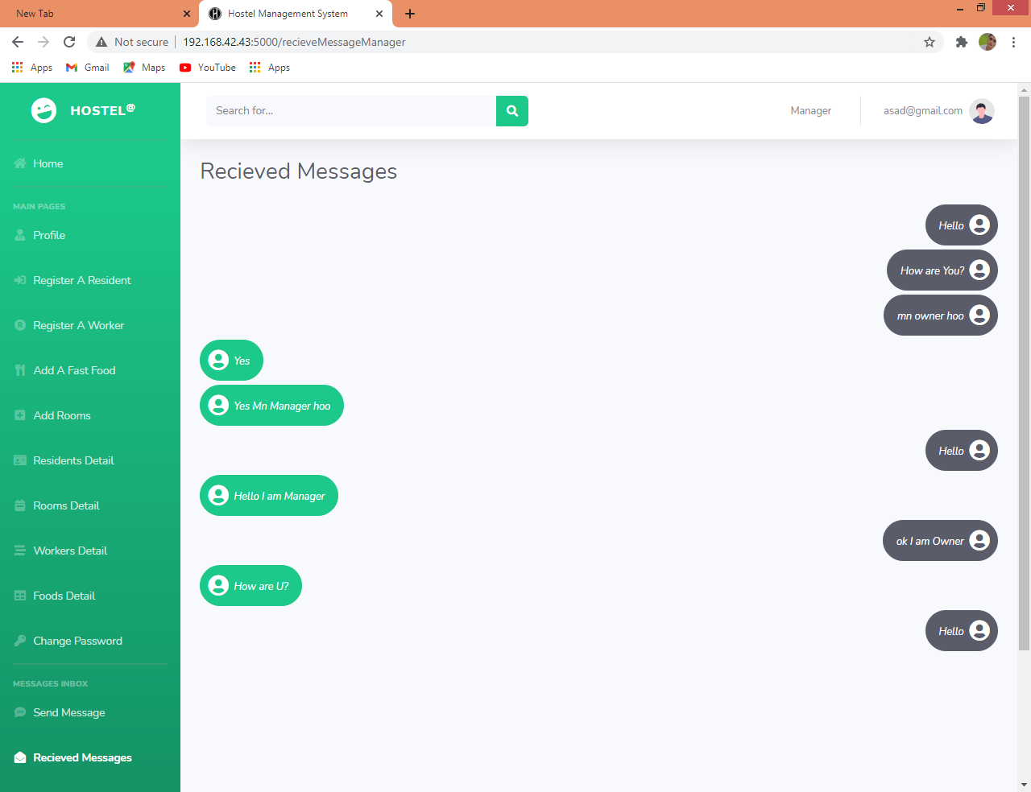

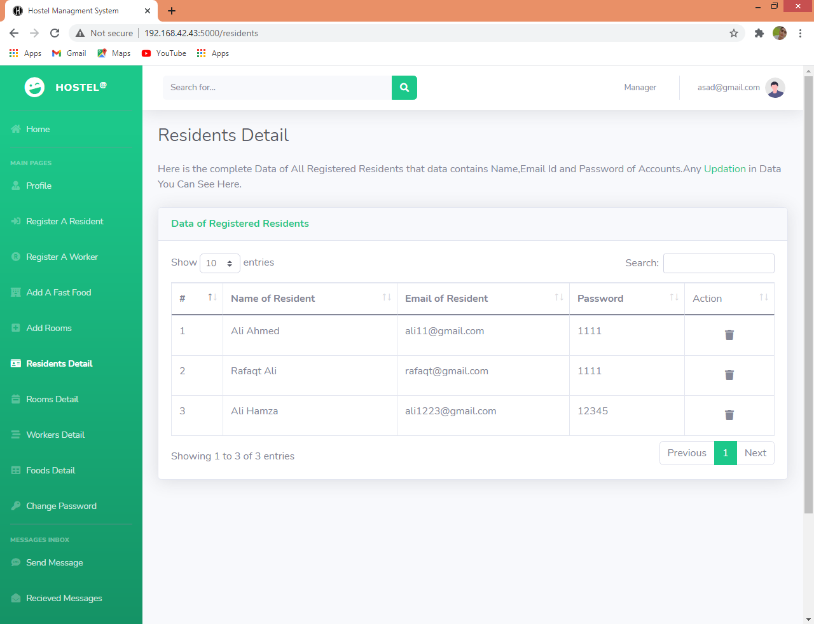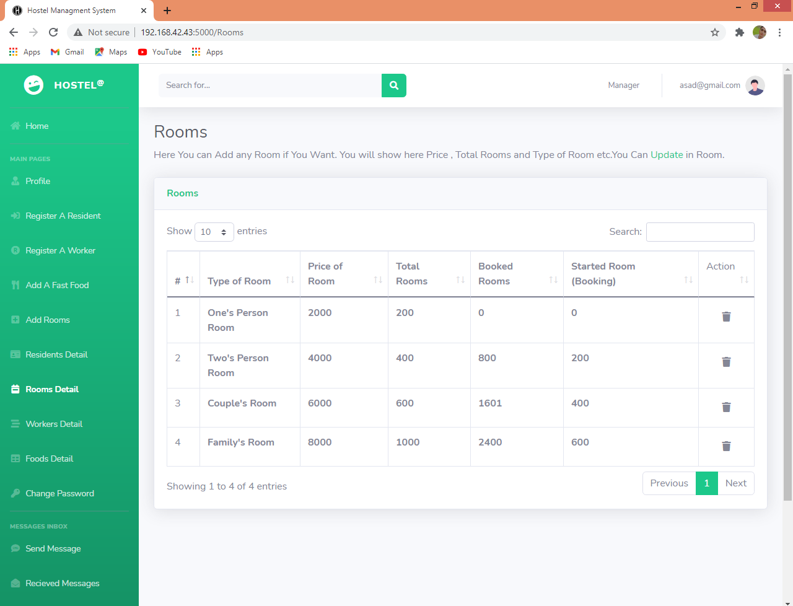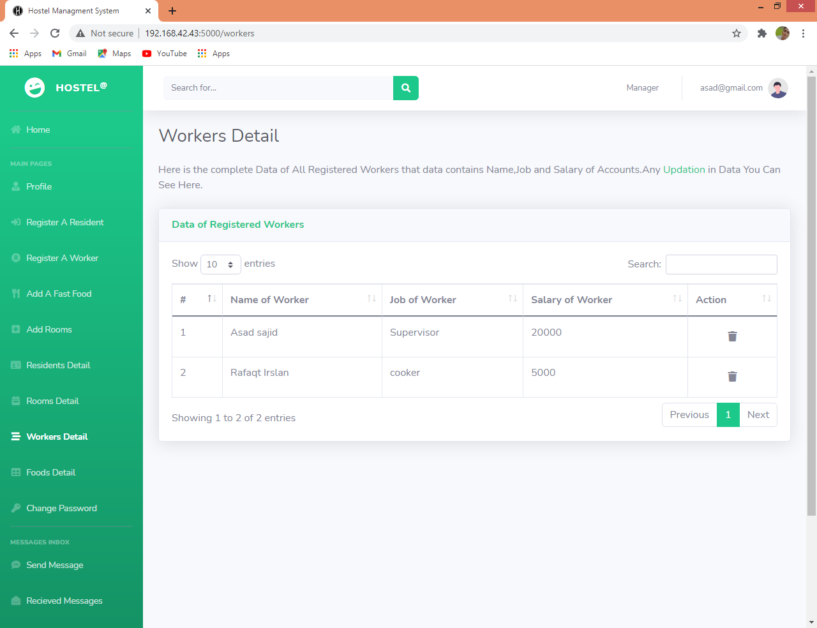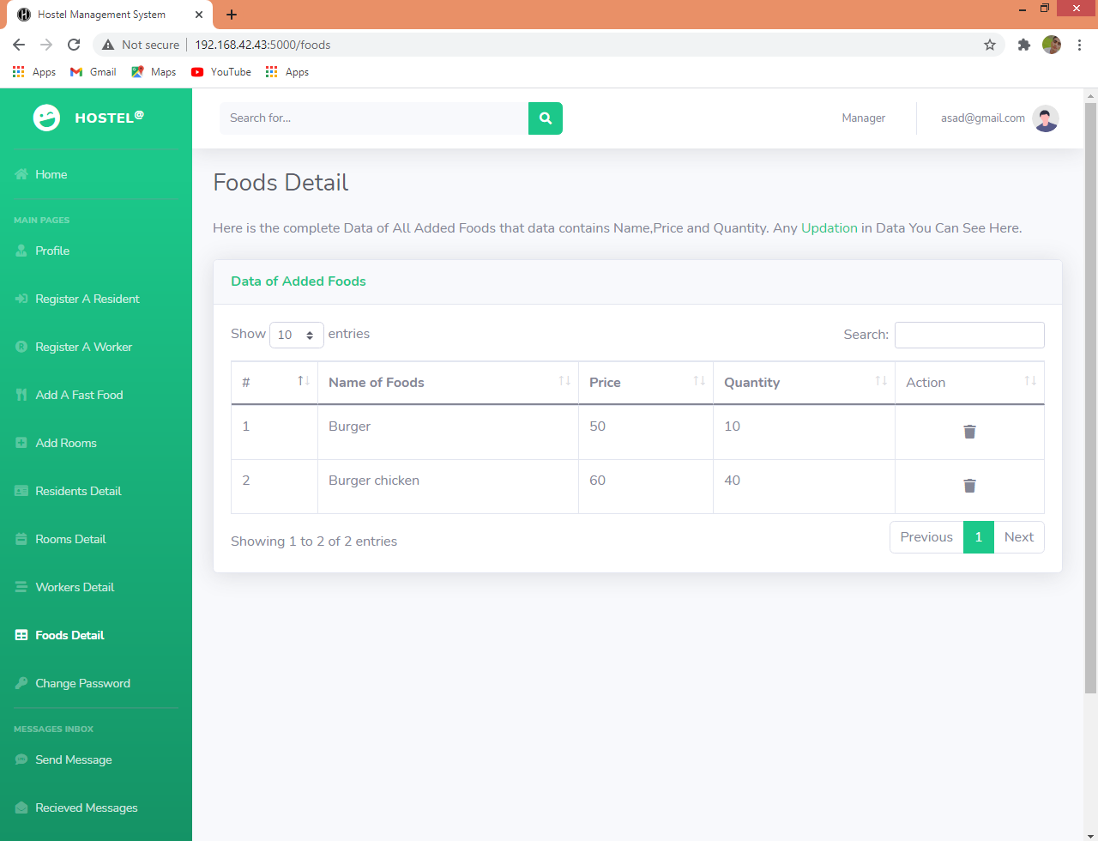

**Resident Login Page:**

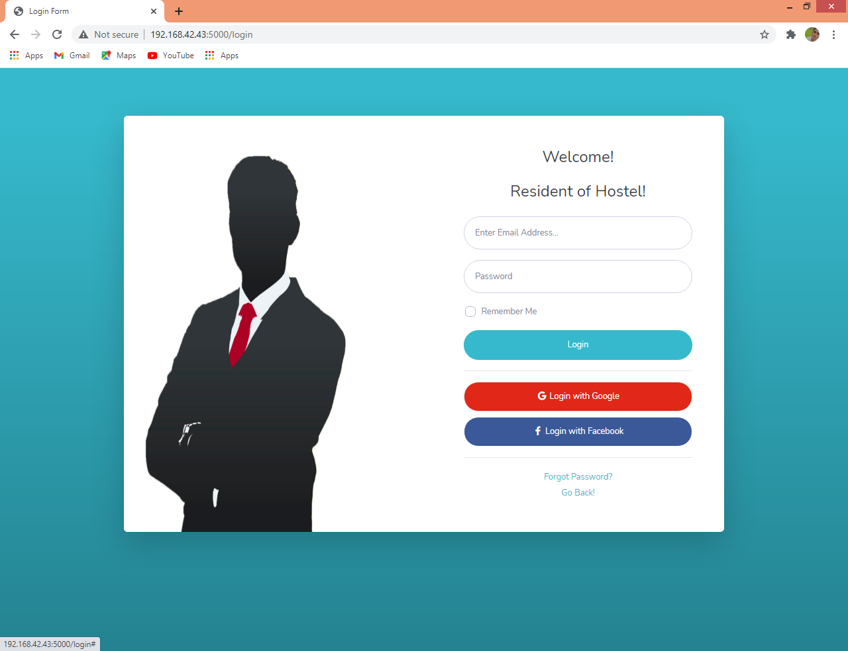

**Resident Page:**

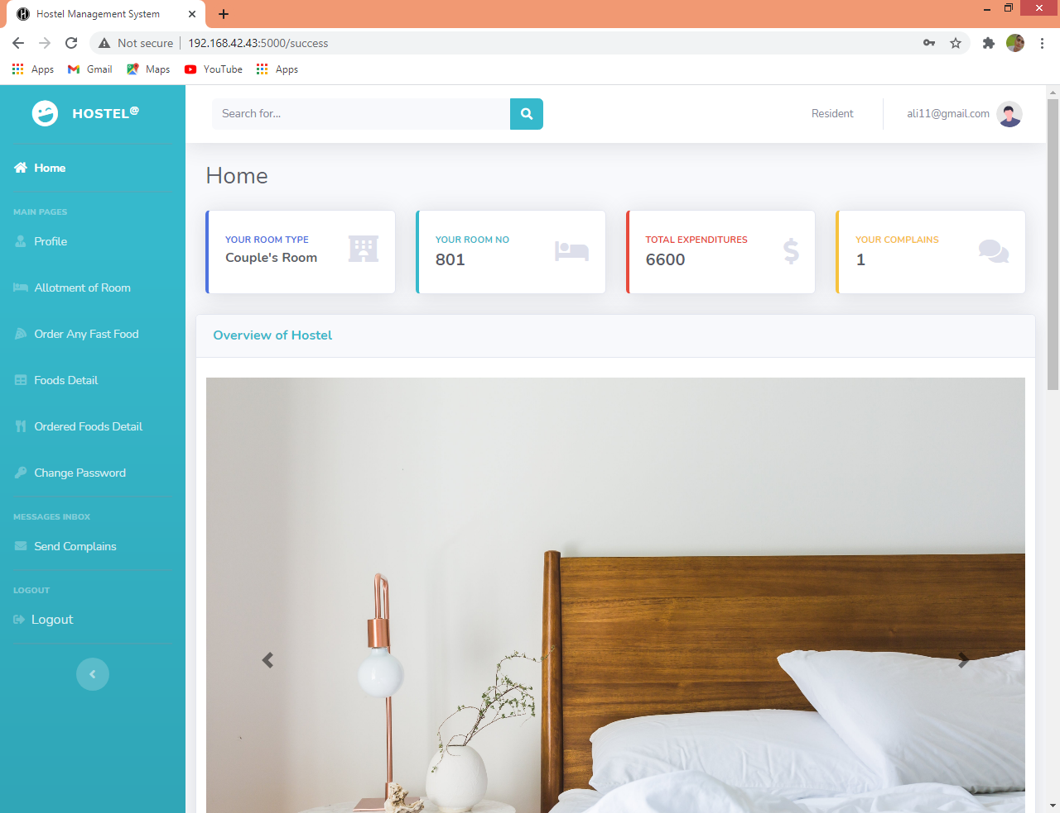

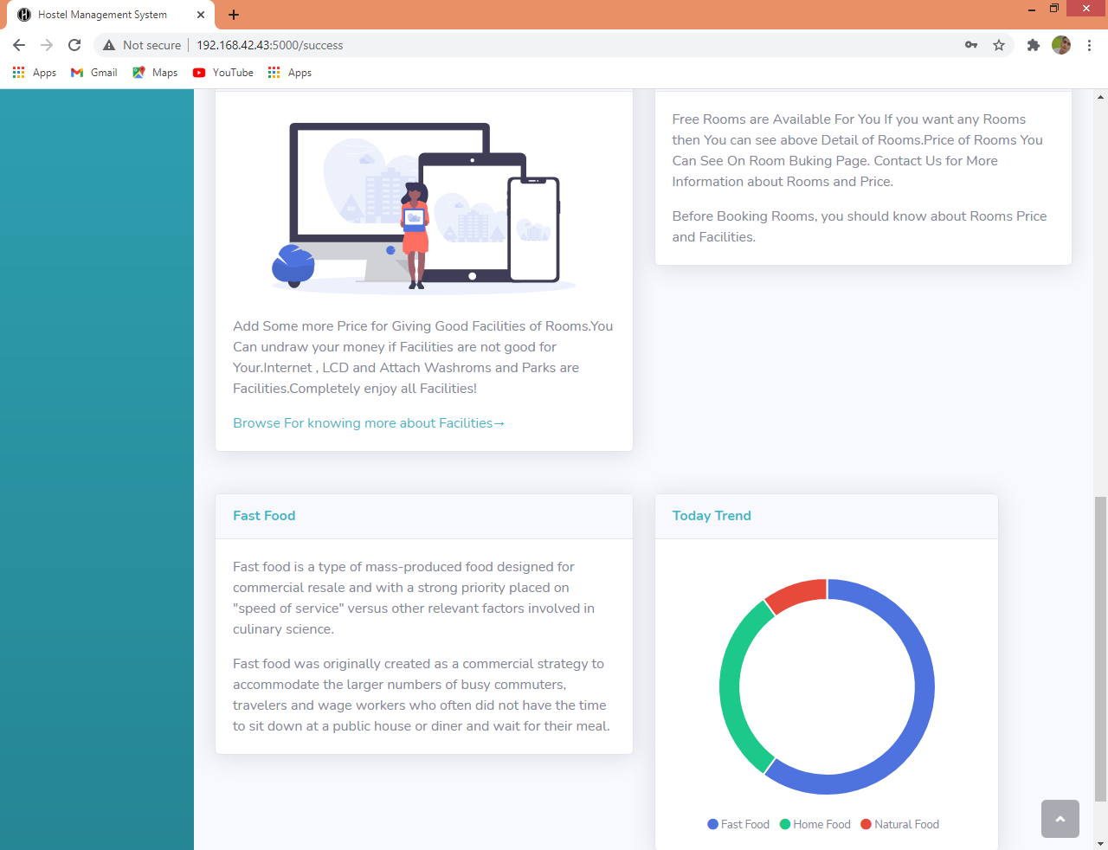

**Other People:** 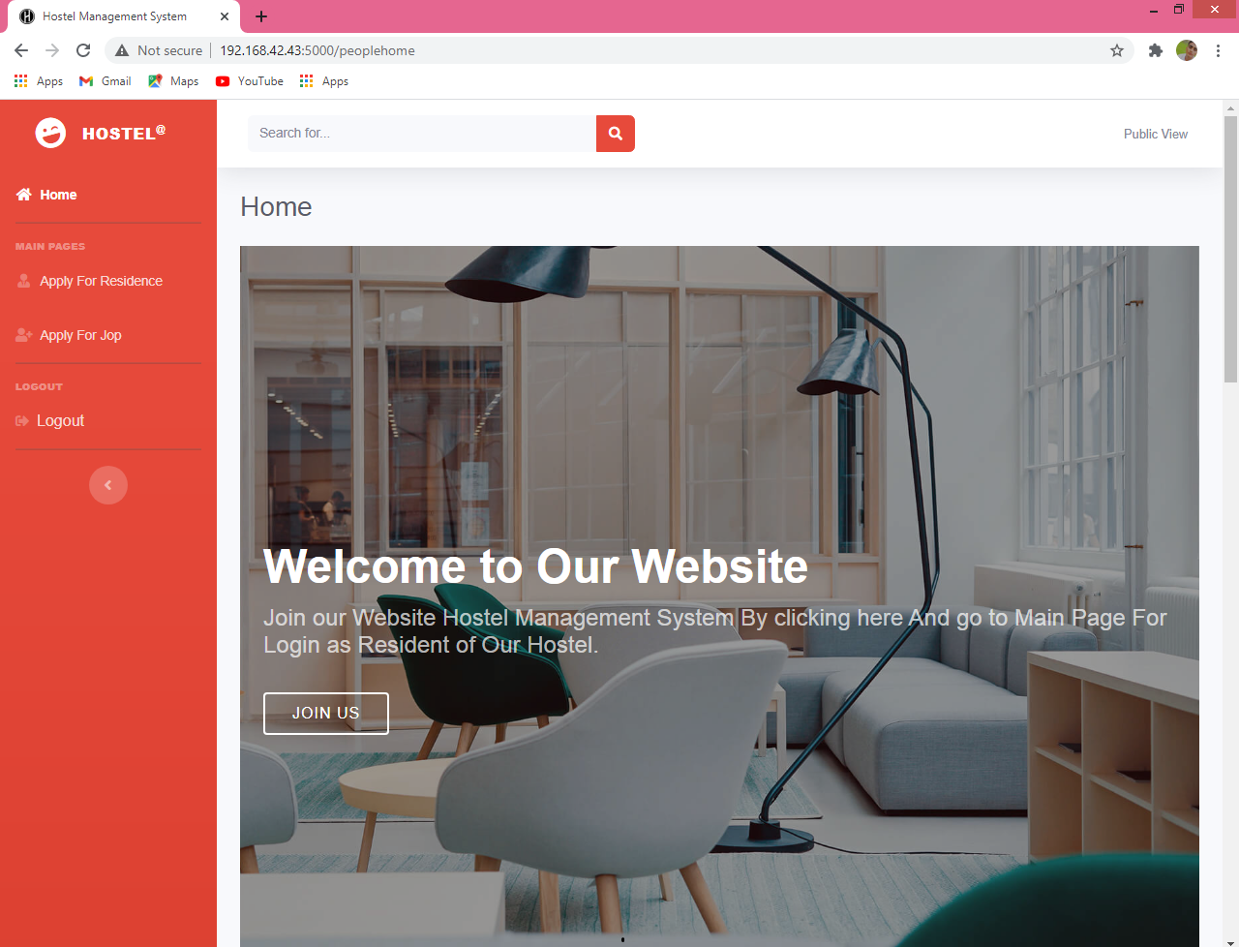

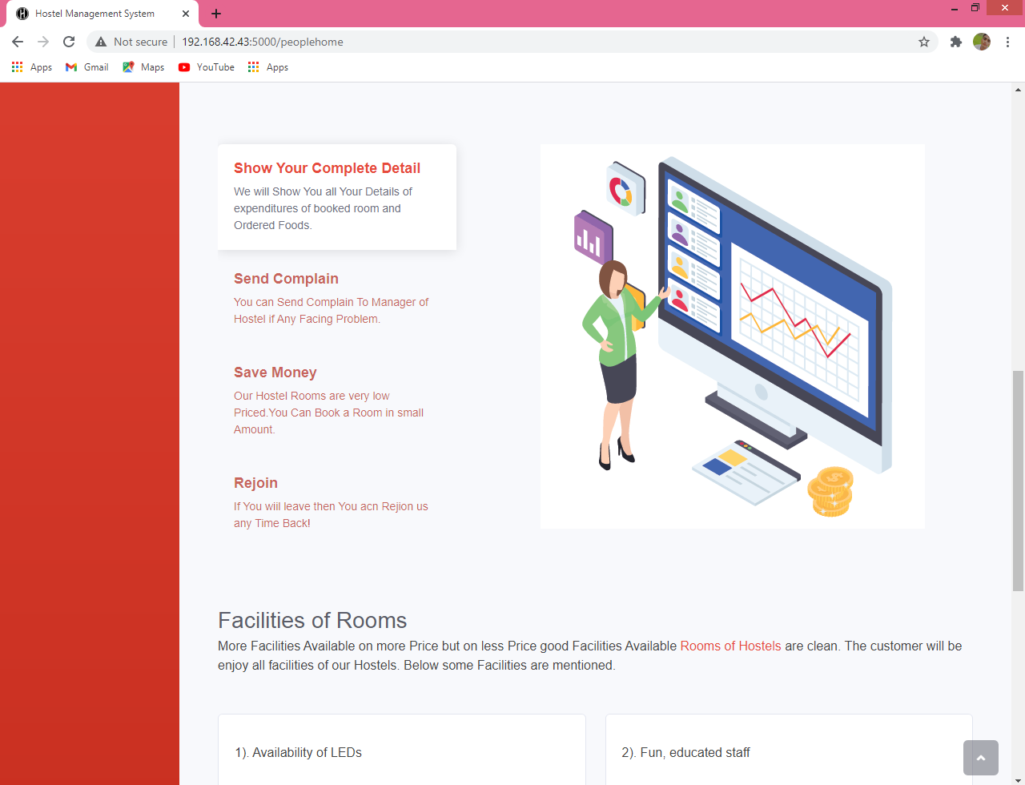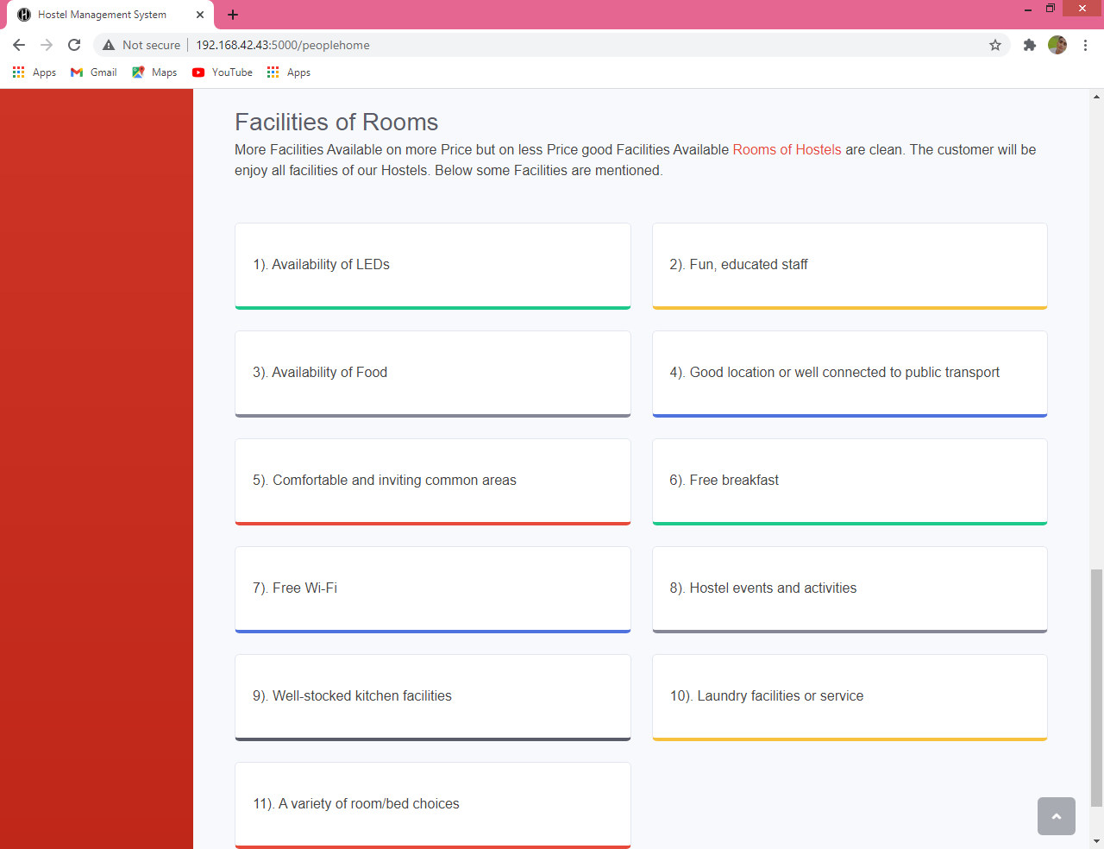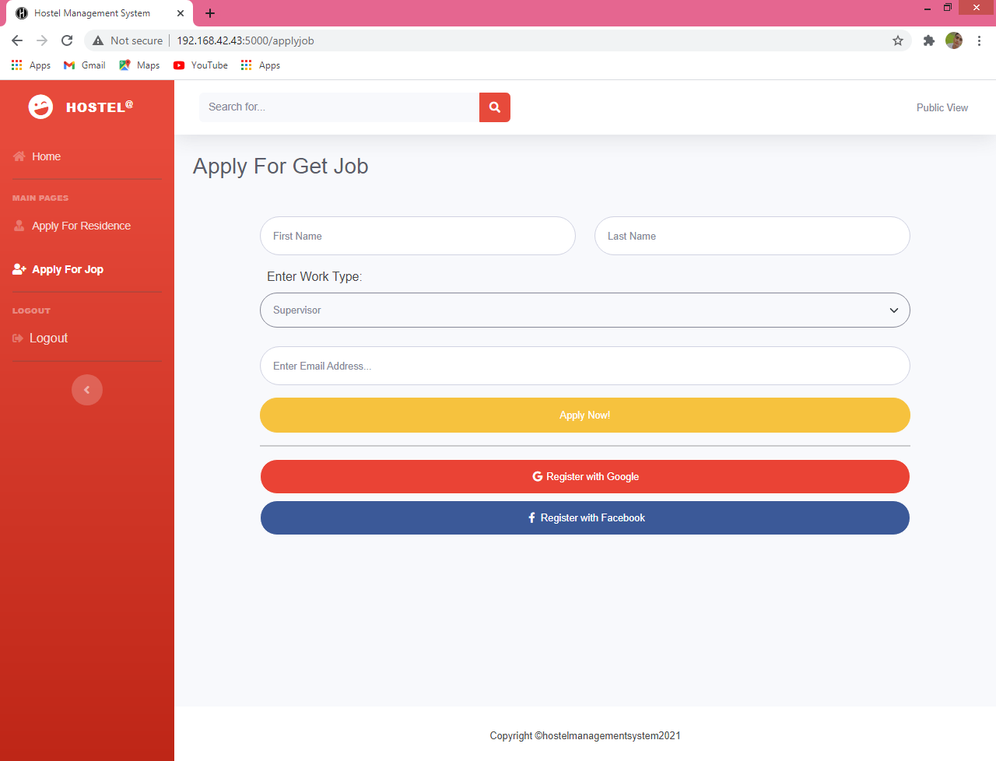

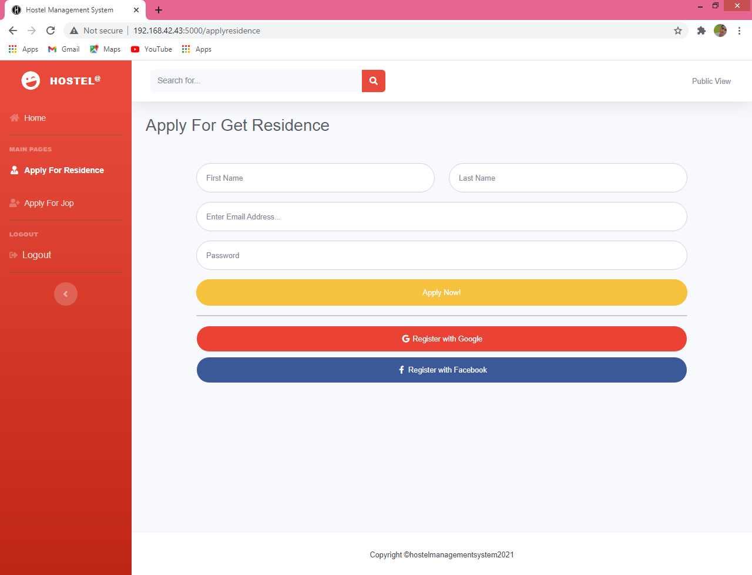

**Sequence Diagram:**

Manager

Resident

Owner

Get_info()

Write Into File

Send Message

Send_Successfully

Get_info()

Write Into File

Send Message

Send_Successfully

Get_info()

Write into File

Send Complain

Send_Successfully

Get_Info()

Write into File

Get Room Number

Get Successfully

**Test Cases:**

Login Forms:

* Invalid Email & Password Cannot be Enter into Main Pages (Positive)
* Verify proper style of input email (Positive)
* Empty Input cannot be Send Data into Backend (Positive)
* Remember me Not Working (Negative)
* Login with Gmail or Facebook not working (Negative)
* Forgot Password Working Well (Positive)

Owner Page:

* Send Message check Input is Empty or Not (Positive)
* Add Manager Check Proper Email , Password , First and Last Name (Positive)
* Verify Email before changing Password (Positive)

Manager Page:

* Send Message check Input is Empty or Not (Positive)
* Add Worker and Resident Check Proper Email , Password , First and Last Name (Positive)
* Verify Email before changing Password (Positive)
* Can Delete Any Resident or Worker (Positive)

Resident Page:

* Send Message check Input is Empty or Not (Positive)
* Verify Email before changing Password (Positive)
* For Allotment and Order Food Check Email And Password before that (Positive)
* For Allotment check already Have Room or Not (Positive)

**Added Features:**

* Added Public View Option
* Added Add Worker Option in Manager Menu
* Added View Detail of Worker Option in Manager Menu
* Added View All Ordered Foods Option in Residents Menu
* Added Add Room Type Option in Manager Option
* Added Forgot Password Option in Login
* Added Home Pages